**C64 Kernal Adapter/Switch (Long Board) Rev. 2**

**Module Description**

# Introduction

The board serves for adapting the KERNAL ROM U4 (type 2364) to a 27C512 (or 27C256, 27C128, 27C64) EPROM. The pin out of both ICs are slightly different and need adaptation. Furthermore, it allows to access (up to 8) different kernals, which can be selected via the pin-header on the module.

This pin-header is connected in a way, that the selection can either be accomplished with standard 2.54mm jumper bridges, DIP-switches, hex-encoding switches or a microcontroller like an Arduino etc.

|  |  |  |  |
| --- | --- | --- | --- |
| **Signal** | **Pin** | **Pin** | **Signal** |
| A13 | 1 | 2 | GND |
| A14 | 3 | 4 | GND |
| A15 | 5 | 6 | GND |
| +5V | 7 | 8 | +5V |

Table 1: Jumper (JP1) for Bank Selection

The +5V pins are to provide supply voltage to a microcontroller.

# Dimensions

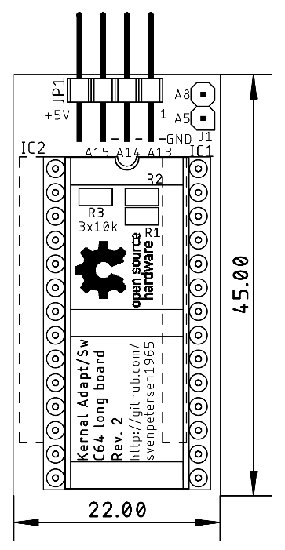

Figure 1: Kernal Adapter/Switch

# Bank Selection

The desired KERNAL is selected at JP1. For the pinout refer to Table 1. The jumper is installed (vertically) in a way, that it connects the address line with the GND potential.

|  |  |  |  |  |
| --- | --- | --- | --- | --- |
| A15 | A14 | A13 | 8k Block | Addr. Offset |
| set | set | set | #0 | 0x0000 |
| set | set | open | #1 | 0x2000 |
| set | open | set | #2 | 0x4000 |
| set | open | open | #3 | 0x6000 |
| open | set | set | #4 | 0x8000 |
| open | set | open | #5 | 0xA000 |
| open | open | set | #6 | 0xC000 |
| open | open | open | #7 | 0xE000 |

Table 2: Selection of EPROM memory blocks

A set jumper corresponds to a LOW level (binary 0), an open jumper to a HIGH level. Do not confuse the C64 memory address and the EPROM memory address. They have the address Bit A0 to A12 in common, but the rest is different. Each of the 8k blocks appears between address $E000 and $FFFF of the C64.

# Sources for KERNAL

The content of the KERNAL ROM can be found here:

<http://www.zimmers.net/anonftp/pub/cbm/firmware/computers/c64/index.html> ([kernal.901227-03.bin](http://www.zimmers.net/anonftp/pub/cbm/firmware/computers/c64/kernal.901227-03.bin))

This file includes the original KERNAL (Rev. 3) and could be loaded to the lowest 8k of the EPROM. In case it is desired to have the original in bank#0. Also Scandinavian KERNAL ROMs can be found at the URL mentioned before or can alternatively be obtained from the Emulator Software VICE (./C64/kernal).

Alternative kernals can be found elsewhere on internet. A reliable source is

<https://csdb.dk/>

The popular JiffyDOS is still a commercial product and can be acquired for little money from

<http://www.go4retro.com/> or

JaffyDOS is a patch for JiffyDOS. The patch program can be obtained from World of Jani:

[http://blog.worldofjani.com](http://blog.worldofjani.com/)

# Setting up an EPROM image

Combining the desired ROM (*.bin) files to one programming image works with the software of the programmer. This might a different with different model. Here it is demonstrated using the popular TL866. In case the programmer software does not provide the function, a Hex Editor like HxD will do the job.

The first KERNAL ROM has to be loaded into the buffer like this:

File → Open → Select the BASIC ROM

Use default file load options (Figure 2):

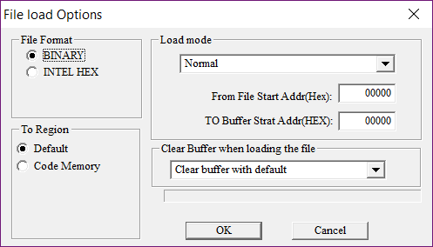

Figure 2: Default load options, clear buffer with default

Now this Kernal is loaded. It will occupy the addresses 0000 – 1FFF.

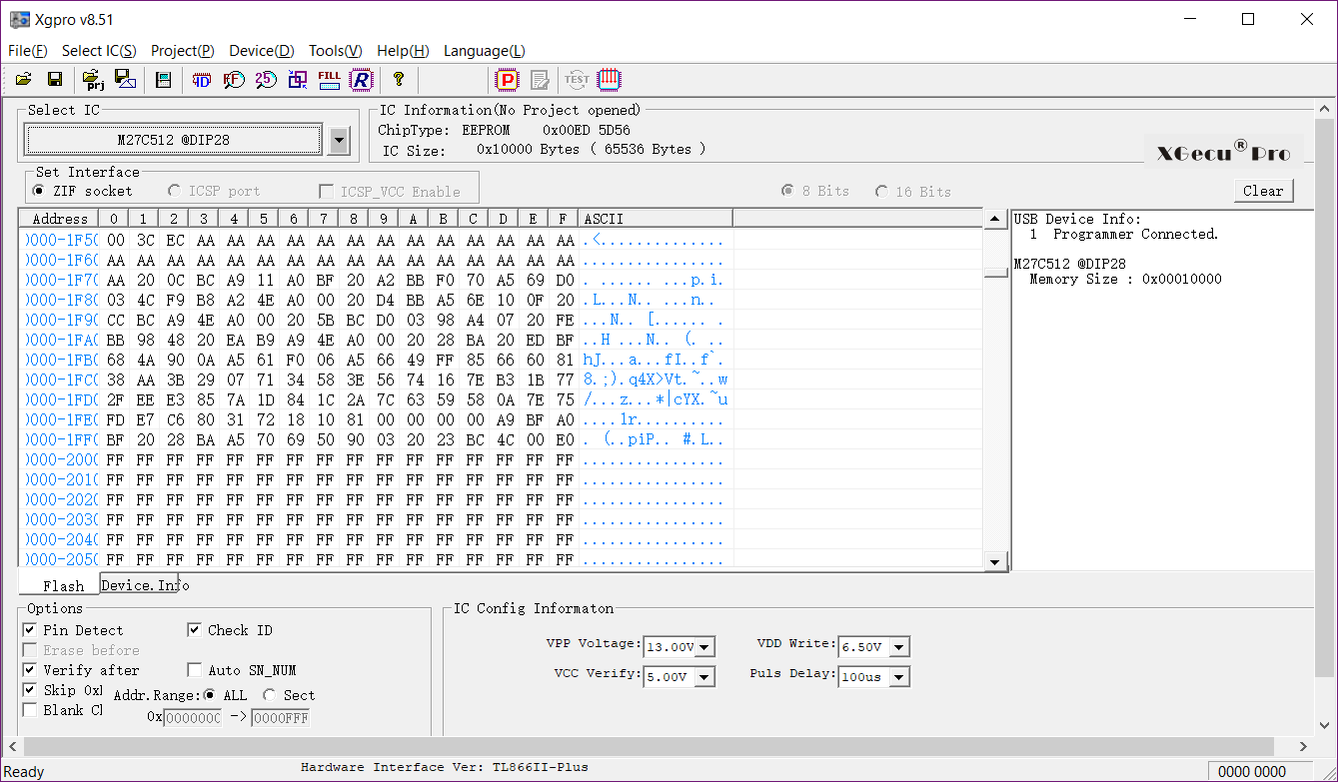

Figure 3: Buffer content after BASIC was loaded

The buffer above 1FFF is still empty (filled with FF, Figure 3).

The next KERNAL has to be loaded to the next free 8k memory block in the buffer. Please refer to Table 2. Further, it is important, not to clear the buffer. Otherwise, the BASIC will be lost and the EPROM will not work. Refer to Figure 4.

Clear Buffer when loading file is disabled, the address for the first kernal is 2000HEX

Repeat this procedure with the appropriate buffer/EPROM address, until all desired kernals are in the buffer. Store the buffer for later use, insert a blank EPROM and program it. Insert it in the Kernal Adapter/Switch.

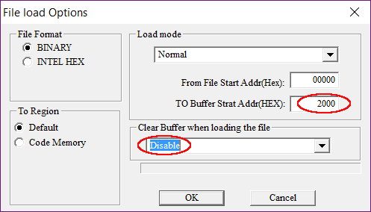

Figure 4: Load options for the first KERNAL

# Adding more Kernals to an already programmed EPROM

In case the unused 8k memory slots of the EPROM are filled with FF, it is still possible to program additional kernel images without erasing them before. FF is the content of an empty byte in an EPROM. It is possible to alter such a byte to every other byte content. Before the new memory is written, the prior content can be read into the program buffer, then a free 8k slot is determined and the kernel is loaded into that slot. Refer to chapter “Setting up an EPROM image”. Now, the buffer content can be programmed. It is possible to program the complete buffer, the bytes already programmed will (usually) not be corrupted and after programming, the EPROM will verify ok.

# Installation

In some cases, the KERNAL ROM (U4) has to be unsoldered and a socket (preferably round pin precision contacts) has to be installed, before the Kernal Adapter/Switch can be installed on the Long Board. The notch of the EPROM is pointing towards the user port, when installed properly (Figure 5).

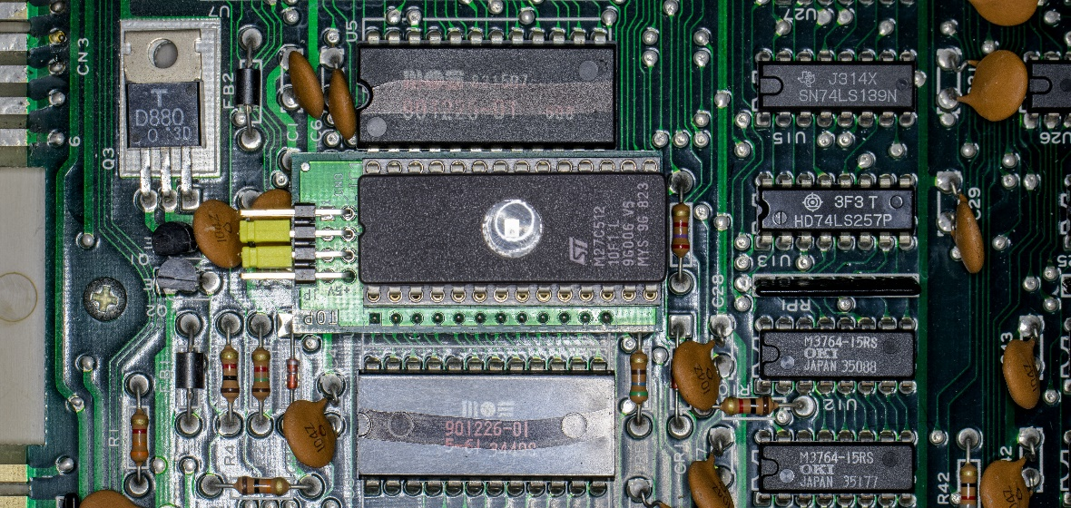

Figure 5: Installation of the Kernal Adapter/Switch

The capacitor under the board needs to be bent a bit backwards in order not to collide with it.

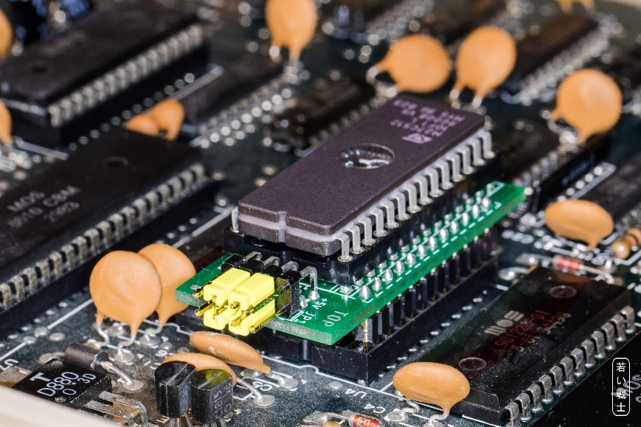

Figure 6: Parts under the adapter board

# Compatibility of EPROMs

Although a 27C512 type EPROM is recommended, other types of EPROMs can be installed:

|  |  |  |
| --- | --- | --- |
| EPROM | Size | Capacity |
| 27C64 | 8k | 1x KERNAL |
| 27C128 | 16k | 2x KERNAL |
| 27C256 | 32k | 4x KERNAL |
| 27C512 | 64k | 8x KERNAL |

Table 3: Capacity of EPROM types

Those EPROMs are pin compatible, the jumpers, that have no function, due to the size, have to stay open.

|  |  |  |  |  |
| --- | --- | --- | --- | --- |
| EPROM | Size | A15 | A14 | A13 |
| 27C512 | 64kx8 | 🗹 | 🗹 | 🗹 |
| 27C256 | 32kx8 | open | 🗹 | 🗹 |
| 27C128 | 16kx8 | open | open | 🗹 |
| 27c64 | 8kx8 | open | open | open |

Table 4: Settings per EPROM type

🗹: The jumper can be open or closed, depending on the desired selection.

In case Vpp is located at a dedicated pin (pin 1), A15 has no effect anymore. A HIGH level is recommended, the corresponding jumper is open. The /PGM Pin should be set HIGH, this is accomplished by an open jumper for A14. “n.c.” means not connected. Just leave the jumper open for it.

|  |  |  |  |  |  |  |  |  |  |  |  |
| --- | --- | --- | --- | --- | --- | --- | --- | --- | --- | --- | --- |
| 27C64 | | | | | | | | | | | |
|  | 27C128 | | | | | | | | | |  |
|  | 27C256 | | | | | | | |  |
|  | 27C512 | | | | | |  |
|  | SOCKET | | | |  |
| Vpp | Vpp | Vpp | A15 | 1 | A15 | VCC | 28 | VCC | VCC | VCC | VCC |
| A12 | A12 | A12 | A12 | 2 | A12 | A14 | 27 | A14 | A14 | /PGM | /PGM |
| A7 | A7 | A7 | A7 | 3 | A7 | A13 | 26 | A13 | A13 | A13 | n.c. |
| A6 | A6 | A6 | A6 | 4 | A6 | A8 | 25 | A8 | A8 | A8 | A8 |
| A5 | A5 | A5 | A5 | 5 | A5 | A9 | 24 | A9 | A9 | A9 | A9 |
| A4 | A4 | A4 | A4 | 6 | A4 | A11 | 23 | A11 | A11 | A11 | A11 |
| A3 | A3 | A3 | A3 | 7 | A3 | /OE | 22 | /G/Vpp | /G | /G | /G |
| A2 | A2 | A2 | A2 | 8 | A2 | A10 | 21 | A10 | A10 | A10 | A10 |
| A1 | A1 | A1 | A1 | 9 | A1 | GND | 20 | /E | /E | /E | /E |
| A0 | A0 | A0 | A0 | 10 | A0 | D7 | 19 | D7 | D7 | D7 | D7 |
| D0 | D0 | D0 | D0 | 11 | D0 | D6 | 18 | D6 | D6 | D6 | D6 |
| D1 | D1 | D1 | D1 | 12 | D1 | D5 | 17 | D5 | D5 | D5 | D5 |
| D2 | D2 | D2 | D2 | 13 | D2 | D4 | 16 | D4 | D4 | D4 | D4 |
| GND | GND | GND | GND | 14 | GND | D3 | 15 | D3 | D3 | D3 | D3 |

Table 5: EPROM pin compatibility

# Startup and Trouble shooting

Before you insert the Kernal Adaptor/Switch into the socket of U4, you should make sure, that there are no fatal failures on it. In the worst case, it will produce a short circuit.

* Check the solder joints on the solder side
* Check the orientation of the socket. The notch is oriented to the side, where the jumper is located
* Make sure, that no jumper is installed horizontally. This could connect GND and VCC, which is a short circuit.
* After inserting the EPROM, check if the notch is at the same side like the notch of the socket. Check all pins are properly seated in the socket and not bent inwards or outwards.

After all these points are correct, nothing really bad can happen to your C64 anymore. If you get a black screen you only have a configuration problem.

* Did you program the EPROM with a proper *.bin file? (*.rom) Maybe check the buffer content of your programmed software again.
* Did you set the address bits A13…A15 correctly? A set (closed) jumper means LOW

# Revision History

## Rev. 0 → Rev. 1

* Solder Pads for the pin header JP1 is ready for solder bridges
* Pin 8 of JP1 is not connected

## Rev. 1 → Rev. 2

* J1 is new and providing A5 and A8 for stereo SID applications